PREDICTING THE ENERGY OUTPUT OF
WIND TURBINE BASED ON WEATHER CONDITION

A PROJECT REPORT

Submitted by

DERICK PRINCE.J
BYSONE PRINCE.S
DIALING DIJOE.X
BALAJI.K

In partial fulfilment for the award of the degree

Of

BACHELOR OF ENGINEERING

IN

ELECTRONICS AND COMMUNICATION ENGINEERING

PONJESLY COLLEGE OF ENGINEERING, NAGERCOIL-3

ANNA UNIVERSITY: CHENNAI- 600025

NOV 2022

ANNA UNIVERSITY: CHENNAI-600025

BONAFIDE CERTIFICATE

Certified that this project report “PREDICTING THE ENERGY OUTPUT OF WIND TERBINE BASED ON WEATHER CONDITION” is the bonafide work of “DERICK PRINCE (961819106018),
BYSONE PRINCE (961819106014), DIALING DIJOE (961819106024), BALAJI
(961819106009)” who carried out the project work under my supervision.

SIGNATURE SIGNATURE

Dr M. R. Geetha Mr. Deiva Thaya Sweetlin
HEAD OF THE DEOARTMENT MENTER

Assistant Professor

Electronics and Communication Electronics and Communication
Engineering Engineering

Ponjesly College Of Engineering Ponjesly College Of Engineering,
Nagercoil-3 Nagercoil-3

CONTENTS

1.ABSTRACT

2.INTRODUCTION

3.RELATED WORK

4.MACHINE LEARNING
i)SKILLS REQUIRED
ii) PROJECT DESCRIPTION
iii)TECHNICAL ARCHITECTURE

5.PREQUISITES

6.PRE COLLECTION

7.DATA PRE-PROCESSING
i)LOAD THE DATASET
ii)IMPORT REQUIRED LIBRARIES
iii)ANALYSIS THE DATASET
iV)SPLITING DEPENDENT AND INDEPENT VARIABLE

8.APPLICATION BUILDING

9.CONCLUSION AND FUTURE SCOPE

10.IDEATION PHASE

11.PROJECT DESIGN PHASE –-1

12.PROJECT DESIGN PHASE—2

13.PROJECT PLANNING PHASE

14.OUTPUT SHOW
15.REFERENCES
Github-Demo link:

ABSTRACT:

The purpose of the project is to predict the electricity output based on the rotating speed of the wind turbines; here we get the output based on the previous data. In this we have two independent variables LV Active Power, Wind Speed and two dependent variable Theoretical Power and wind direction. For that we use one of the regression algorithm like polynomial regression and predict the output by using r2_score.In this we train the model with the previous data and test the data by giving the independent variables and predicting whether it is giving expected output or not. We use a node red for deploying the nodes, we used http request, timestamp, for sending the message we used message payload, for power detection we used theoretical power, inputs as Active Power and Wind Speed and to implement the user interface. There are two steps in the process of wind power prediction. In the first step raw data is collected by the power plant information system and is filtered. This prepares a valid data to be used for building a prediction model. In the second step we use all the regression algorithms to build a model to predict the wind power. It is to achieve a high accuracy with respect to the measured data.

INTRODUCTION:

Wind plant has lower cost of energy compared to other renewable energy source for large scale application. Due to the different geographical patterns, weather, and properties of the wind turbines, a wind turbine may have various performances given different situations. If the total output of a wind power plant can be predicted with high accuracy, more useful information can be provided to the power companies to help in scheduling the power generation. This information will allow a more flexible and intelligent control at a WPP (Wind power Plant). Methods for predicting wind power generation can be categorized into physical methods, statistical methods, methods based on neural networks, and hybrid methods. The physical methods rely heavily on numeric whether prediction, which is confined by the sensors and monitoring devices placed within the WPP. The quality of hardware chosen, the parameters settings, the computation time, the time delay, and the sampling rates influence the accuracy of data collected from the WPP. It is easier to predict a single wind turbines performance rather than a whole WPP power generation. Statistical and neural networks methods are based on the historical data and have a low prediction cost. The relationship between input data and output data based on the historical measured data is learned and then a nonlinear relationship model between them is built. But when new data not previously included in the training data set is used as input into this kind of model, the prediction error might be large, which is a disadvantage. Different prediction methods mentioned above can be combined as hybrid methods to achieve better prediction results. But this will increase the complexity of the model. In this paper, multiple linear regressions are applied to predict the power generation at wind power plant.

In this WPP, data of wind information, such as wind speed, wind direction, wind power generation, humidity and air pressure are collected by a Plant Information (PI) system.
• The raw data set will be screened by probabilistic neural network to prepare high quality data for building neural network models.
• The model's inputs do not rely on the data of wind speed and wind direction from all turbines; representative wind turbines can be found to compress the length of the input data.
• The inputs are expressed as complex-valued data (vector representation) which combine wind speed and wind direction.
• The complex-valued recurrent neural network model's time series inputs are generated based on the historical data values of the WPP rather than the predicted values by the model at the previous steps.
• The result to be predicted is the total power generation of the whole WPP rather than outputs of some single wind turbines.

The evaluation of wind potential in a region requires systematic data collection and analysis on wind speed and regime. Generally, a rigorous assessment requires specific surveys of the region where the wind farm will be placed. There are three major markets for the field of global wind power generation: Europe, USA and China. Wind energy penetration levels continue to rise, led by Denmark with a 40% use of this energy, followed by Uruguay, Portugal and Ireland with over 20%; Spain and Cyprus with about 20%; Germany with 16%; and the major markets of China, the US and Canada with 4%, 5.5% and 6% wind energy, respectively. The forecast of five years ahead is almost 60 GW of new wind power installations in 2017, rising to an annual market of 75 GW by 2021, and an accumulated installed capacity of more than 800GW by the end of 202. Wind energy is a clean and renewable alternative for the production of electric energy, presenting great socialacceptance. In the social feature, wind power plants do not cause major environmental impacts such as in hydroelectric plants and allow the compatibility between the production of electricity from the wind and the use of land for livestock and agriculture. Wind generation occurs through the contact of the wind with the blades of the wind device. When rotating, these blades convert wind speed into mechanical energy that drives the rotor of the wind generator, which produces electricity. According to, tropical regions receive solar rays almost perpendicularly and are therefore warmer than the Polar Regions.

RELATED WORK:

Research objectives are prepared after correlating the various works done by contemporary researchers. Most of the researchers have developed methods for wind speed based forecasting. Apart from wind speed forecasting, many other parameters required to assess the wind energy potential are studied. Meteorological information coupled with topographical data has to be utilized for wind power estimation at a particular place. After this, wind turbine power curves have to be mapped against the wind parameters. [1] This is to establish the number of energy units that can be generated at wind plant level, for a month. In most of the wind plants in India, wind speed measurements taken from a single location for the whole plant which is an average indicator of wind power potential at plant level. Deviations from mean position of the wind measurement to the wind turbine are not considered. Hence, Average wind speed indicator continues to contribute for wind 38 power estimation at plant level. Wind speed and wind power generation along with changing values across time series in the present focus of work.
Wind power forecasts associated with wind resource assessment methodologies, data and experience through modeling will help the wind power plants to meet the changing grid requirements. [1] Forecasting serves two purposes – allows wind generators to take operational decisions which are aligned to market prices of energy, allows the system operator to better plan ancillary services required to balance generation from variable renewable energy sources.
Wind power estimation models are majorly classified as models based on physical or numerical weather prediction models, statistical models. [1] Physical models are based on the meteorological data and open boundary fluid flow equations. Other energy equations are solved as nonlinear solvers in predicting wind energy potential of selected space.
A number of different approaches have been applied to forecast wind speed and the power produced by wind farms. Potter and Negnevitsky [2] applied the adaptive neurons fuzzy inference approach to forecast short-term wind speed and direction.
Barbounis et al. [2] used the nonlinear recursive least-squares method to train a recurrent neural network (NN) based on the meteorological data. Their model has improved the accuracy of long-term wind speed and power forecasting. Damousiset al.[8] developed a fuzzy logic model and trained it with a genetic algorithm. The model was then used to forecast wind speed over horizons ranging from 0.5 to 2 h. Li et al. [2] compared regression and NN models for wind turbine power estimation, and reported that the NN model outperformed the regression model. Sfetsos [2] presented a novel method to forecast the mean hourly wind speed using a time series analysis, and showed that the developed model outperformed the conventional forecasting models.
Developing prediction models for wind farms is a challenge, as the power is mainly determined by the wind speed that is difficult to forecast accurately. [3] The wind speed depends on parameters such as air pressure, temperature, terrain topography, etc. The stochastic nature of a wind farm environment calls for new modeling approaches to accurately predict the power to be produced in the future time periods.
Two different methodologies for power prediction have been employed. [3] The models are built using historical data collected by supervisory control and data acquisition (SCADA) systems installed at a wind farm. A short-term power prediction is important in dispatching power to meet customer needs. For long horizon predictions, meteorological data are usually used.
In this paper, we take a computer science perspective on energy prediction based on weather data and analyze the important parameters as well as their correlation on the energy output. To deal with the interaction of the different parameters, we use symbolic regression based on the genetic programming tool DataModeler. Our studies are carried out on publicly available weather and energy data for a wind farm in Australia. We report on the correlation of the different variables for the energy output. [4] The model obtained for energy prediction gives a very reliable prediction of the energy output for newly supplied weather data.
Genetic programming has its main success stories in the field of symbolic regression. Given a set of input output vectors, the task is to find a function that maps the input to the output as best as possible, while avoiding over fitting. [4] The resulting function is later often used to predict the output for a newly given input. Syntax trees represent functions in this case, and the functions are changed by crossover and mutation to produce new functions. The quality of a syntax tree is determined by how well it maps the given set of inputs to their corresponding outputs.
Wind energy plays an increasing role in the supply of energy world wide. [5] The energy output of a wind farm is highly dependent on the weather conditions present at its site. [5] If the output can be predicted more accurately, energy suppliers can coordinate the collaborative production of different energy sources more efficiently to avoid costly overproduction. In this paper, we take a computer science perspective on energy prediction based on weather data and analyze the important parameters as well as their correlation on the energy output. [6] To deal with the interaction of the different parameters, we use symbolic regression based on the genetic programming tool DataModeller. Our studies are carried out on publicly available weather and energy data for a wind farm in Australia. [6] We report on the correlation of the different variables for the energy output. The model obtained for energy prediction gives a very reliable prediction of the energy output for newly supplied weather data

MACHINE LEARNING :
i)SKILLS REQUIRED :
Python,Python Web Frame Works,Python For Data Visualization,Data Preprocessing Techniques,Machine Learning,IBM Cloud,IBM Watson Studio,Python-Flask
ii)PROJECT DESCRIPTION :
Wind power generation differs from conventional thermal generation due to the stochastic nature of wind. Thus wind power forecasting plays a key role in dealing with the challenges of balancing supply and demand in any electricity system, given the uncertainty associated with the wind farm power output. Accurate wind power forecasting reduces the need for additional balancing energy and reserve power to integrate wind power. For a wind farm that converts wind energy into electricity power, a real-time prediction system of the output power is significant. In this guided project , a prediction system is developed with a method of combining statistical models and physical models. In this system, the inlet condition of the wind farm is forecasted by the auto regressive model.

iii)TECHNICAL ARCHITECTURE :

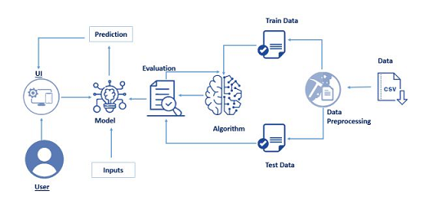
PREREQUISITES :
Step 1:
Anaconda Navigator :
Anaconda Navigator is a free and open-source distribution of the Python and R programming languages for data science and machine learning related applications. It can be installed on Windows, Linux, and macOS. Conda is an open-source, cross-platform, package management system. Anaconda comes with great tools like JupyterLab, Jupyter Notebook, QtConsole, Spyder, Glueviz, Orange
For this project, we will be using Jupyter notebook and Spyder
Step 2:
To build Machine learning models you must require the following packages
Sklearn: Scikit-learn is a library in Python that provides many unsupervised andsupervisedlearningalgorithms.
NumPy: NumPy is a Python package that stands for 'Numerical Python'. It is the core library for scientificcomputing, which contains a powerful n-dimensionaarrayobject
Pandas: pandas is a fast, powerful, flexible, and easy to use open-source data analysis and manipulation tool, built on top of the Python programming language.
Matplotlib: It provides an object-oriented API for embedding plots into applications using general-purpose GUI toolkits

If you are using anaconda navigator, follow the below steps to download the required packages:
- Open anaconda prompt.
- Type“pip install numpy” and click enter.
- Type “pip install pandas”and click enter.
- Type“pip install matplotlib” and click enter.
- Type “pip install scikit-learn”and click enter.
- Type“pip install Flask” and click enter.

If you are using Pycharm IDE, you can install the packages through the command prompt and follow the same syntax as above.

PRE COLLECTION :
ML depends heavily on data, without data a machine can't learn. It is the most crucial aspect that makes algorithm training possible. In Machine Learning projects, we need a training data set. It is the actual data set used to train the model for performing various actions.

i)SKILL TAGS :
The dataset for wind energy prediction is to be collected. The dataset which is considered here will have the environmental conditions. You can collect datasets from different open sources like kaggle.com, data.gov, UCI machine learning repository, etc.

ii)DATASET :
T1.CSV

DATA PRE-PROCESSING :
i)LOAD THE DATASET :
from google.colab import files
uploaded=files.upload()
This code is usde for lode our selectable dataset.

ii)IMPORT REQUIRED LIBRARIES :
import pandas as pd
import numpy as np
import sklearn
import matplotlib.pyplot as plt
import seaborn as sns

iii)ANALYSIS THE DATASET :
data = pd.read_csv("T1.csv")
This one use to read the dataset.
#head funtion and tail funtion
data.head()
this one run the dataset and it will be excecute the first five rows.
data = data.rename(columns = {"Date/Time":"Date",
"LV ActivePower (kW)":"Active_Power",
"Wind Speed (m/s)":"Wind_Speed",
"Theoretical_Power_Curve (KWh)":"Theoretical_Power",
"Wind Direction (°)" :"Wind_Direction"
})
data.tail() #last 5 rows of the dataset
above the code will be run the dataset and display a last five rows.
#shape of the dataset
data.shape
It dsplay the size or shape of the dataset.
SATISTICAL ANALYSIS :
data.mean()
data.median()
data.mode()
data.var()
data.std()
data.describe()
data['Active_Power'].unique ()
data['Theoretical_Power'].unique()
data['Active_Power'].value_counts ()
data['Theoretical_Power'].value_counts ()

DATA VISUALIZATION :
1.Uni varient analysis
Only one variable is run here.
sns.distplot(data['Active_Power'])
sns.distplot(data['Wind_Speed'])
sns.distplot(data['Theoretical_Power'])
sns.distplot(data['Wind_Direction'])
sns.histplot(data['Active_Power'])
sns.histplot(data['Wind_Speed'])
sns.histplot(data['Theoretical_Power'])
sns.histplot(data['Wind_Direction'])
sns.boxplot(data['Active_Power'])
sns.boxplot(data['Theoretical_Power'])
sns.boxplot(data['Wind_Direction'])
sns.boxplot(data['Wind_Speed'])
2.Bi varient analysis
Run between two variable.
sns.lineplot(data['Active_Power'], data['Theoretical_Power'])
sns.scatterplot(data['Active_Power'], data['Theoretical_Power'])
sns.lineplot(data['Theoretical_Power'], data['Wind_Direction'])
sns.scatterplot(data['Theoretical_Power'], data['Wind_Direction'])
sns.lineplot(data['Theoretical_Power'], data['Wind_Speed'])
sns.scatterplot(data['Theoretical_Power'], data['Wind_Speed'])
sns.lineplot(data['Active_Power'], data['Wind_Speed'])
sns.scatterplot(data['Active_Power'], data['Wind_Speed'])
3.Multi varient analysis
Run between above two variable.
sns.scatterplot(data['Active_Power'], data['Theoretical_Power'], hue = data['Wind_Speed'])
sns.scatterplot(data['Active_Power'], data['Theoretical_Power'], hue = data['Wind_Direction'])
sns.pairplot(data)
data.corr()
sns.heatmap(data.corr())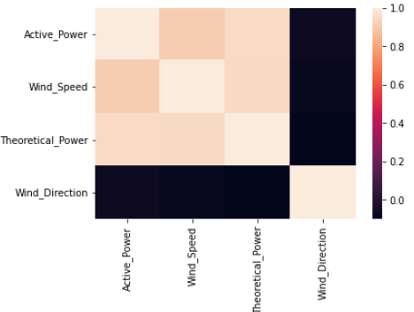
MISSING VALUES :
#missing values

data.isna().sum()
data.isnull().any()
data.isnull().sum()
data.mode()
data['Active_Power'].unique()
data['Active_Power'].value_counts
REPLACE OUTLIER :
data.describe()
sns.boxplot(data['Wind_Speed'])
# position of the outlier
print(np.where(data['Wind_Speed']>20))

q = data.quantile([0.25,0.75])
q

iqr = q.iloc[0] - q.iloc[1]
iqr

u = q.iloc[0] + (1.5*iqr) # q3 + 1.5*iqr
u

## handling outliers

data['Wind_Speed'] = np.where(data['Wind_Speed']>5,4,data['Wind_Speed'])
sns.boxplot(data['Wind_Speed'])
data['Active_Power'],data['Wind_Speed'].unique()

ENCODING PERFORM :
# converting categorical values into numericalvalues - Encoding Here There is no categorical valus
data.head()

#statisticak overview of the data
data.describe().T

#scatterplot
plt.scatter(data['Theoretical_Power'],data['Wind_Speed'])
iv)SPLITING DEPENDENT AND INDEPENDENT VARIABLE :
#split the data

x=x = data[["Theoretical_Power", "Wind_Speed"]]
y=data["Active_Power"]

x=x = data[["Theoretical_Power", "Wind_Speed"]].values
y=data["Active_Power"].values
x
y

LV Active Power(kW):

A very simple and effective means to eliminate leading or lagging power factor errors, reduce voltage fluctuations, enhance equipment operating life and improve system power capacity. The range offers consolidated features in one package without the risk of resonance, while stabilizing electrical networks by providing harmonic mitigation, power factor correction and load balancing.
In a simple alternating current (AC) circuit consisting of a source and a linear load, both the current and voltage are sinusoidal If the load is purely resistive, the two quantities reverse their polarity at the same time. At every instant the product of voltage and current is positive or zero, the result being that the direction of energy flow does not reverse. In this case, only active power is transferred.
Wind speed (m/s):

Wind speed is affected by a number of factors and situations, operating on varying scales (from micro to macro scales). These include the pressure gradient, Rossby waves and jet streams, and local weather conditions. There are also links to be found between wind speed and wind direction, notably with the pressure gradient and terrain conditions.
Wind speeds usually mean the movement of air in an outside environment, but the speed of movement of air inside is also important in many cases,including weatherforecasting, aircraft and maritime operations, construction and civil engineering. High wind speeds can cause unpleasant side effects, and strong winds often have special names,including gales, hurricanes, and typhoons.
Theoretical power curve(KWh):

The power of a binary hypothesis test is the probability that the test rejects the null hypothesis (H0) when a specific alternative hypothesis (H1) is true. The statistical power ranges from 0 to 1, and as statistical power increases, the probability of making a type II error (wrongly failing to reject the null hypothesis) decreases. For a type II error probability of β, the corresponding statistical power is 1-β. For example, if experiment 1 has a statistical power of 0.7, and experiment 2 has a statistical power of 0.95, then there is a stronger probability that experiment 1 had a type II error than experiment 2, and experiment 2 is more reliable than experiment 1 due to the reduction in probability of a type II error. It can be equivalently thought of as the probability of accepting the alternative hypothesis (H1) when it is true that is, the ability of a test to detect a specific effect, if that specific effect actually exists
Wind direction:
Wind direction is reported by the direction from which it originates. For example, a northerly wind blows from the north to the south.[1] Wind direction is usually reported in cardinal directions or in azimuth degrees. Wind direction is measured in degrees clockwise from due north. Consequently, a wind blowing from the north has a wind direction of 0° (360°); a wind blowing from the east has a wind direction of 90°; a wind blowing from the south has a wind direction of 180°; and a wind blowing from the west has a wind direction of 270°. In general, wind directions are measured in units from 0° to 360°, but can alternatively be expressed from -180° to 180°.

APPLICATION BUILDING :
from flask import Flask, jsonify, request
from datetime import datetime
from datetime import timedelta
import requests
import json
import math
import pickle
import pandas as pd
app = Flask(__name__)
# Creating the instance of Flask app
model = pickle.load(open('model.pkl','rb'))
# Loading the ML model into a variable for prediction

def getWeatherData(latitude,longitude):
now = datetime.now() + timedelta(minutes=330)
# Server is in UK so setting it to IST
startTime = now.strftime("%Y-%m-%dT%H:%M:%SZ")
end = now + timedelta(hours=71)
# We need 72 hours data so fixing start and end time
endTime = end.strftime("%Y-%m-%dT%H:%M:%SZ")
customUrl = 'start_time='+startTime+'&end_time='+endTime+'&lat='+latitude+'&lon='+longitude
apiUrl = 'https://api.climacell.co/v3/weather/forecast/hourly?unit_system=us&fields=temp,wind_speed,baro_pressure,humidity&apikey=f27af3a577aaaf874418898f15b3e661'
# The URL which will retrieve data from Climacell API
response = requests.get(apiUrl+customUrl)
# Response stored in a variable
if response:
return response.json() # Returning json format of response

def round_up(n, decimals=0):
multiplier = 10 ** decimals
return math.ceil(n * multiplier) / multiplier
# To achieve values till 4 places after decimal

def tempFunc(data,power):
# This function will form the object to be sent to front-end
arrObj = []
for i,en in enumerate(data):
jsonObj = {}
jsonObj['power'] = round_up(power[i],4)
jsonObj['date'] = en['observation_time']['value'][0:10]
jsonObj['time'] = en['observation_time']['value'][11:19]
jsonObj['wind_speed'] = str(en['wind_speed']['value'])
jsonObj['temperature'] = str(en['temp']['value'])
jsonObj['humidity'] = str(en['humidity']['value'])
jsonObj['pressure'] = str(en['baro_pressure']['value'])
arrObj.append(jsonObj)
return arrObj;
@app.route('/predict', methods=['GET','POST'])
def predictor():
if request.method == "GET":
latitude = request.args.get('latitude')
longitude = request.args.get('longitude')
# Receiving latitude and longitude values from front-end
weatherJson = getWeatherData(latitude,longitude)

# Storing the weather data in weatherJson variable
jsonList=[]
windlist = []
templist = []
humidlist = []
preslist = []
for ele in weatherJson:
windlist.append(ele['wind_speed']['value'])
templist.append(ele['temp']['value'])
humidlist.append(ele['humidity']['value'])
preslist.append(ele['baro_pressure']['value'])

# Creating weather variable list to be fed to model for prediction
myDict = {
'Wind_Speed_(miles/h)' : windlist,
'Temperature' : templist,
'Humidity' : humidlist,
'Pressure' : preslist
}

inpt_df = pd.DataFrame.from_dict(myDict)
# DataFrame object which is actually accepted by pickle
prediction = model.predict(inpt_df)
# Getting predictions from model and storing it in variable
modelOutput = tempFunc(weatherJson,prediction)
# Getting object to be sent to front-end and storing in a variable
jsonOutput = json.dumps(modelOutput)
# Converting the object into json format
return jsonOutput
# Returning the output to front end
if __name__ == "__main__":
app.run(debug=True)

CONCLUSION AND FUTURE SCOPE:

In this study, we showed that wind energy output can be predicted from publicly available weather data with accuracy up to 80% R2 on the training range and up to 85, 5% on the unseen test data. We identified the smallest space of input variables where reported accuracy can be achieved, and provided clear trade-offs in prediction accuracy when decreasing the input space to the wind speed variable.
We are pleased that the presented framework is so simple that it can be used by literally everybody for predicting Theoretical power based on wind energy production —for individual wind turbines on private farms or urban buildings, or for small wind farms. For future work, we are planning further study of the possibilities for longer-term wind energy forecasting.
Several forecasting models were discussed and a lot of researches on the models, which have their own characteristics, were presented. The major focus was on emphasizing the diversity of various forecasting methods available and also on providing a comparison of present mechanisms to determine the best available.

IDEATION PHASE :
i)Brainstorm & Idea Prioritization Template
Step-1: Team Gathering, Collaboration and Select the Problem Statement

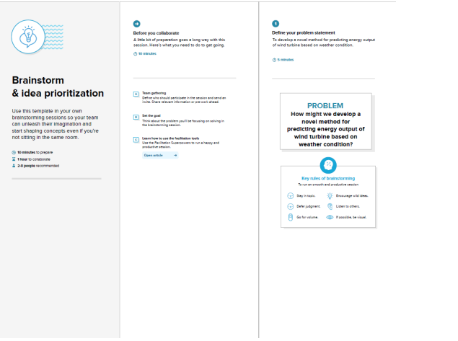
Step-2: Brainstorm, Idea Listing and Grouping
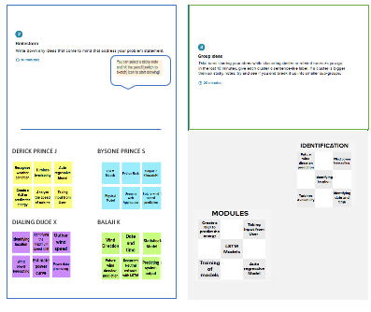
Step-3: Idea Prioritization

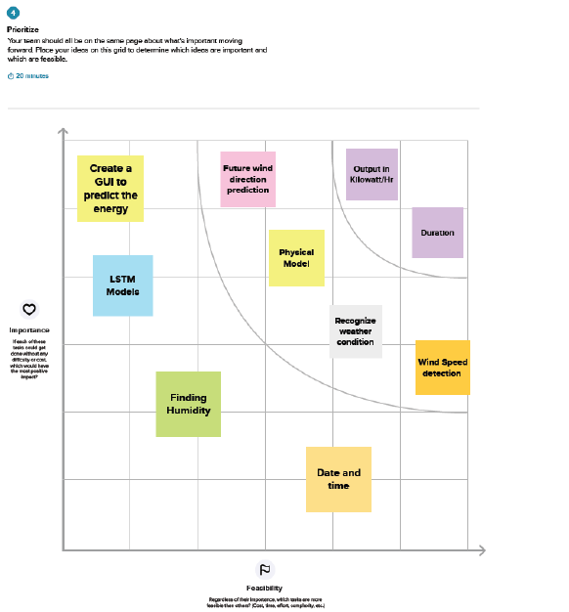
ii)Empathize & Discover

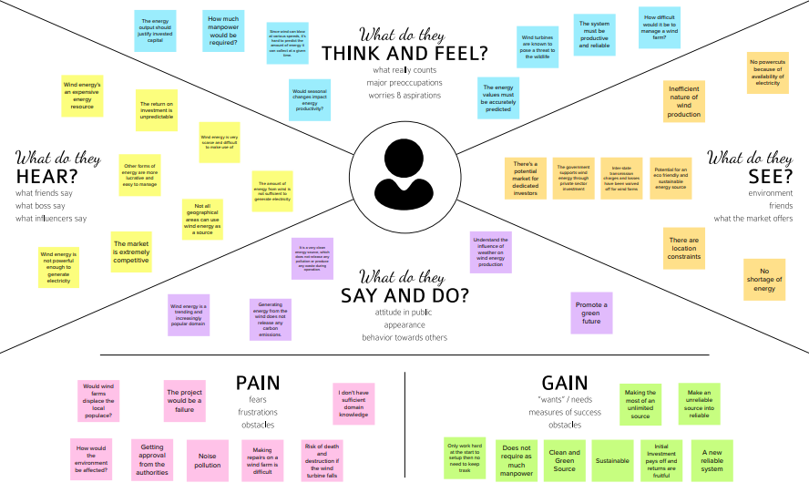

iii)Problem Statement
During the development of generator part for wind turbine, the analysis of eachelement need to be criticized so that the specific component used can be known. Thedetails of type of material used also must consider in order determining the productionof generator part of wind turbine experiment. Therefore, analysis must be done in orderto know the strength and weakness of making the generator part in order to produce theoutput voltage
The ongoing project involves the design of a wind turbine energy conversion system that can be integrated to electrical power grid in the coover hall power lab. It also includes a display system to indicate the output power from the wind turbine. The generator is rated around 400W. The wind turbine will be installed on the roof of the coover hall. All the protection and control aspects of the conversion system become part of the design. The extension of the project includes the design requirements to supply stand alone load in conjunction with the grid supply.

PROJECT DESIGN PHASE 1 :
i)Problem – Solution Fit Template:
The Problem-Solution Fit simply means that you have found a problem with your customer and that the solution you have realized for it actually solves the customer’s problem. It helps entrepreneurs, marketers and corporate innovators identify behavioral patterns and recognize what would work and why
Purpose :
❑ Solve complex problems in a way that fits the state of your customers.
❑ Succeed faster and increase your solution adoption by tapping into existing mediums and channels of behavior.
❑ Sharpen your communication and marketing strategy with the right triggers and messaging.
❑ Increase touch-points with your company by finding the right problem-behavior fit and building trust by solving frequent annoyances, or urgent or costly problems.
❑ Understand the existing situation in order to improve it for your target group

ii)Proposed Solution Template :
- 1,000% wind energy A strong wind blows across the north-western part of the Jutland peninsula, and many wind turbines, solar cells and local CHP plants cover the equivalent of several hundred per cent of the annual electricity consumption. Jysk Energi operates the distribution company NOE Net and is co-owner of the supply network company Vestjyske Net 60 kV. Together, they supply approx. 430 GWh of electricity to their customers. Local electricity production is around 935 GWh. During windy weekends, the distributor sends off more than ten times the local consumption to other parts of the country. At NOE Net, wind turbines, CHP plants and solar cells cover more than 1,000% of the local electricity consumption over shorter periods. Wind turbine capacity alone is close to 400 MW, and with 7-8 large wind turbine and solar cell projects in 2017 and 2018 – including Vesterhav Nord at 170 MW in the North Sea – capacity will increase to 700 MW (Courtesy: Jysk Energi)
- Energy park harvests energy from wind and sun
In Nørhede-Hjortmose, close to the North Sea, 22 3.3 MW Vestas turbines and 69,000 solar cell panels produce plenty of electricity for the grid. Private investors have installed 72 MW of wind energy and 15.2 MW of solar cells, contributing to the local municipality’s goal to become 100% self-sufficient in green heating and electricity by 2020. Thanks in part to the wind turbines and solar cells, the residents and businesses of the municipality have already reached an estimated coverage of 60%.“Yes, it is a truly spectacular park. The solar cells are installed between the wind turbines and do not bother anyone”, says technical manager Per Nielsen of RAH, who is responsible for the combined network and connection of the solar cells to the 10 kV grid.
- Test scheme in Nissum Bredning
The global wind market players continuously seek opportunities to develop offshore test projects, which potentially reduce production costs of electricity from offshore wind farms and keep offshore wind energy costs competitive. In July 2015, the Danish Energy Agency published a call for applications for tests of new technologies to establish and operate wind energy production offshore. Turbines in the test scheme receive a Contract For Differences of approx. EUR 0.09/kWh (DKK 0.7/kWh) for approx. 11 years and then market price until decommissioning.

5. Giant wind turbine blade captures more energy from the wind
Offshore wind energy is envisioned to play a significant role in the delivery of clean, renewable energy in the future and the cost is constantly reduced. Offshore wind projects coming online today are already delivering power at almost half the price of those finished in 2012 due to increased competition and larger turbines and components. A good example of that is the 88.4-metre blade for offshore application, introduced by LM Wind Power in June 2016. The giant blade is based on a newly developed carbon-glass hybrid technology and has been designed, manufactured and tested to last for 25 years of life offshore, in the harshest weather conditions and roughest seas.
- Historically low bid for offshore wind farm
In November 2016, Vattenfall won the tender to build Kriegers Flak, which at 600 MW will become Denmark’s largest offshore wind farm. The tender price of EUR 49.9/MWh (DKK 372/MWh) also makes Kriegers Flak the cheapest offshore wind project to date. The low price reflects a more mature market for offshore wind energy, with an increasing number of players entering the market, enhancing competition. Furthermore, flexibility and a simple, proven process in the tender procedure handled by the Danish Energy Agency contributed to the success of the low-priced winning bid.
- The world’s most powerful turbine
With an aim to drive down the cost of offshore wind while increasing the energy output per turbine, MHI Vestas Offshore Wind has brought its V164-8.0 MW to market. The nacelle is 20 metres long, 8 metres wide and 8 metres high. Each blade is 80 metres long and weighs more than 35 tonnes. The prototype, located at the Østerild National Test Centre for Large Wind Turbines, broke the energy generation record for a commercially available offshore wind turbine in December 2016 by producing 216,000 kWh over a 24-hour period. MHI Vestas has now uprated the 8 MW wind turbine, enabling it to reach 9 MW at specific site conditions. The increased production will add value to projects and save on Capital Expenditure (CAPEX) costs, as fewer turbines are needed to meet park capacity. In April 2016, the first two commercial 8 MW turbines were commissioned in an onshore project at Made in Denmark.

iii)Solution Architecture :

Many developments and improvements have taken place since the commercialisation of wind technology in the early 1980s, but the basic architecture of the mainstream design has changed very little. Most wind turbines have upwind rotors and are actively yawed to preserve alignment with the wind direction. The three-bladed rotor proliferates and typically has a separate front bearing, with low speed shaft connected to a gearbox that provides an output speed suitable for the most popular four-pole (or two -pole) generators. This general architecture is evident in Figure 3.6. Commonly, with the largest wind turbines, the blade pitch will be varied continuously under active control to regulate power in higher operational wind speeds. Support structures are most commonly tubular steel towers tapering in some way, both in metal wall thickness and in diameter from tower base to tower top. Concrete towers, concrete bases with steel upper sections and lattice towers, are also used but are much less prevalent. Tower height is rather site specific and turbines are commonly available with three or more tower height options.

PROJECT DESIGN PHASE 2 :
i)Customer Journey Maps:

ii)Data Flow Diagrams:

User Stories
Use the below template to list all the user stories for the product.

User Type | Functional Requirement (Epic) | User Story Number | User Story / Task | Acceptance criteria | Priority | Release
Customer (Mobile user) | Registration | USN-1 | As a user, I can register for the application by entering my email, password, and confirming my password. | I can access my account / dashboard | High | Sprint-1
 |  | USN-2 | As a user, I will receive confirmation email once I have registered for the application | I can receive confirmation email & click confirm | High | Sprint-1
 | Login | USN-3 | As a user, I can log into the application by entering email & password | I can access the dashboard | High | Sprint-1
 | Dashboard | USN-4 | User can get information about wind energy.  He can able to see a button called predict energy by clicking the button he can give input. | I can predict for single sample | High | Sprint-1
Customer (Web user) |  | USN-5 | Once I enter the Dashboard I can give input values by choosing a city | I can predict the energy production of selected city | High | Sprint-1
 |  | USN-6 | As a user I can get visual representation of the prediction | I can have single output | High | Sprint-1
 |  | USN-7 | As a user I can view the detailed report of my prediction | I can access details of my process and prediction | Medium | Sprint-1
Customer Care Executive | Documentation | USN-8 | As a helper I can refer the documentation for support and guidance | I can use user manual for guidance | Medium | Sprint-1,2, 3,4
Administrator | Settings | USN-9 | As a developer I can access dashboard’s settings and view the API token | I can view the API token for creating request | Low | Sprint-4
 | Feedback | USN-10 | As a developer I can able to view user feedbacks | I can customize these web page based on feedback | Low | Sprint-4

iii)Solution Requirements :
Functional Requirements:
Following are the functional requirements of the proposed solution.
Following are the functional requirements of the proposed solution. FR No. | Functional Requirement (Epic) | Sub Requirement (Story / Sub-Task)
FR-1 | User Registration | Registration through Form
FR-2 | User Registration | Confirmation via Email
FR-3 | Essentiality | • City name  • Wind speed  • Wind direction  • Weather condition
FR-4 | Output | Energy Predicated in KWh
Non-functional Requirements:
Following are the non-functional requirements of the proposed solution.
FR No. | Non-Functional Requirement | Description
NFR-1 | Usability | • Easy to learn  • User friendly  • Efficient
NFR-2 | Security | Privacy - User can have Own accounts to secure their data.
NFR-3 | Reliability | Wind Energy is reliable because it is both unlimited and domestic
NFR-4 | Visuality | Accuracy is high due to combination of multiple ML models to predict the output .
NFR-5 | Availability | This is a web based application so we can access in any device that have a web browser with good Internet facility.
NFR-6 | Scalability | It can be extended further to provide API which can be used by third party organisations such as Industries, Power suppliers , Governmental ,etc.

vi)Technology Stack :
Technical Architecture:

Table-1 : Components & Technologies:
S. No | Component | Description | Technology
1. | User Interface | Web UI | HTML, CSS, JavaScript
2. | Application Logic-1 | Prediction process | Java / Python
3. | Database | Integer type used to store the collected and examine weather data | MySQL, NoSQL
4. | Cloud Database | Database Service on Cloud | IBM DB2, IBM Cloud DB
5. | File Storage | File storage requirements | IBM Block Storage or Other Storage Service or Local Filesystem
6. | External API | Used to predict weather | IBM Weather API, etc.
7. | Machine Learning Model | This model is developed to predict the rainfall using ML algorithms | Algorithms like regression, classification, clustering and ML models
8. | Infrastructure (Server / Cloud) | Application Deployment on Local System / Cloud  Local Server Configuration: intel i3 with 4GB ram  Cloud Server Configuration :IBM cloud service | Local, IBM Cloud Storage Services

Table-2: Application Characteristics:

S. No | Characteristics | Description | Technology
1. | Open-Source Frameworks | Backend Framework, CSS, Relational Database | PyJWT, Flask, IBM Cloud DB
2. | Security Implementations | Request authentication using JWT Tokens | SHA-256, Encryptions, SSL Certs
3. | Scalable Architecture | Support for Multiple sample prediction using Excel File | Pandas Numpy
4. | Availability | Availability is increased by distributed servers in Cloud VPS | Availability is increased by distributed servers in Cloud VPS
5. | Performance | The application is expected to perform accurate prediction | Auto regressive models

PROJECT PLANNING PHASE :

i)Prepare Milestone :

Sprint | Milestone
Sprint 1 | 1. User registers into the application through entering Email Id, Password and Re entering  Password for confirmation.  2. User receives a confirmation mail to their registered Email.  3. User can also register to the application through a mobile number.  4. User logs in into the website using Email Id and password or through Gmail
Sprint 2 | 1. User can access the dashboard  2. User can enter the required details on weather conditions and get the desired turbine  power output based on the model’s prediction.
Sprint 3 | 1. Application should store the predictions, and these predictions can be used for future  analysis.  2. The data stored should be secure
Sprint 4 | 1. Administrator should properly maintain the website and update it when required.

ii)Sprint Delivery Planning :
Sprint | Functional  Requirement | User Story  Number | User Story/Task | Story Point | Priority | Team Members
Sprint-1 | Building Model-1 | USN-1 | As a use l can request for the wind direction,  Wind speed | 5 | High | Derick Prince J  Balaji KK  Bysone Prince S  Dialing Dijoe X
Sprint-1 |  | USN-2 | As a use l can request for the speed of the wind | 5 | High | Derick Prince J  Balaji KK  Bysone Prince S  Dialing Dijoe X
Sprint-1 |  | USN-3 | As a use l can request for the direction of the wind | 2 | Low | Derick Prince J  Balaji KK  Bysone Prince S  Dialing Dijoe X
Sprint-2 | Building Model-2 | USN-4 | As a use l can find the speed of the wind | 3 | Medium | Derick Prince J  Balaji KK  Bysone Prince S  Dialing Dijoe X
Sprint-2 |  | USN-5 | As a use l can find the direction of the wind | 5 | High | Derick Prince J  Balaji KK  Bysone Prince S  Dialing Dijoe X

Sprint | Functional  Requirement | User Story  Number | User Story/Task | Story Point | Priority | Team Members
Sprint-2 |  | USN-6 | Once I have find the wind direction ,I can use this information to getting high energy output | 6 | Medium | Derick Prince J  Balaji KK  Bysone Prince S  Dialing Dijoe X
Sprint-2 |  | USN-7 | If I get the current wind speed , I can predict the energy output | 7 | High | Derick Prince J  Balaji KK  Bysone Prince S  Dialing Dijoe X
Sprint-3 | Building UI | USN-8 | As a customer when I enter the weather details the website should predict the approximate | 20 | High | Derick Prince J  Balaji KK  Bysone Prince S  Dialing Dijoe X
Sprint-3 |  | USN-9 | As a customer I can access the website to predict the turbine energy output | 20 | Medium | Derick Prince J  Balaji KK  Bysone Prince S  Dialing Dijoe X
Sprint-4 | Hosting , Storage & Deployment | USN-10 | As a customer I wish to store my predictions and make analyses | 10 | Low | Derick Prince J  Balaji KK  Bysone Prince S  Dialing Dijoe X
Sprint-4 |  | USN-11 | As an administrator I should maintain the website and update the website regularly | 10 | Low | Derick Prince J  Balaji KK  Bysone Prince S  Dialing Dijoe X

OUTPUT SHOW :

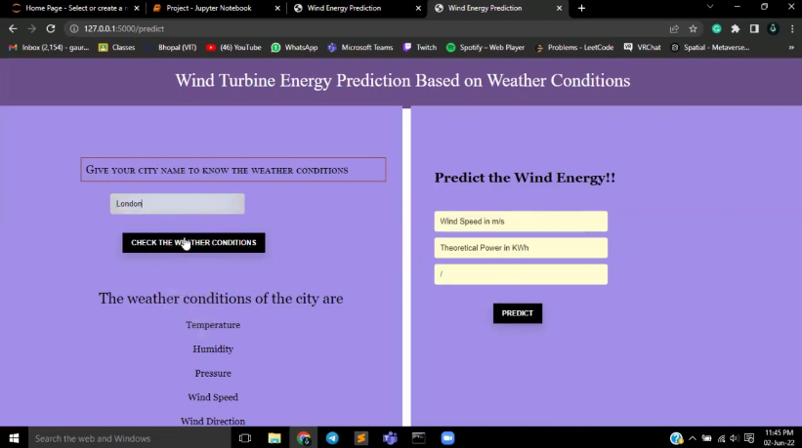
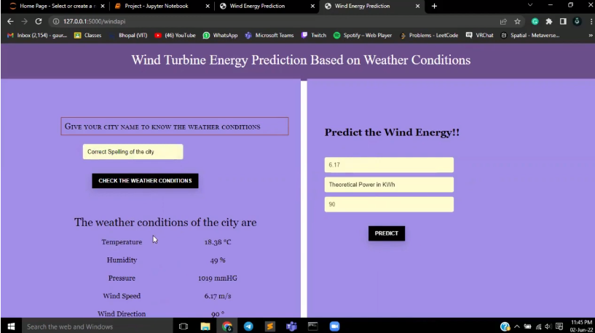

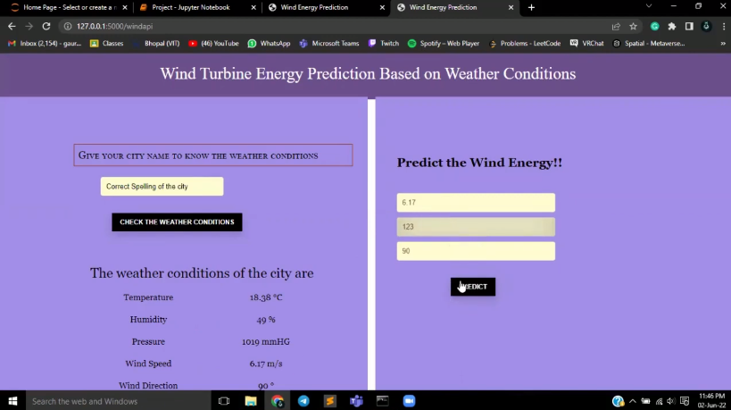

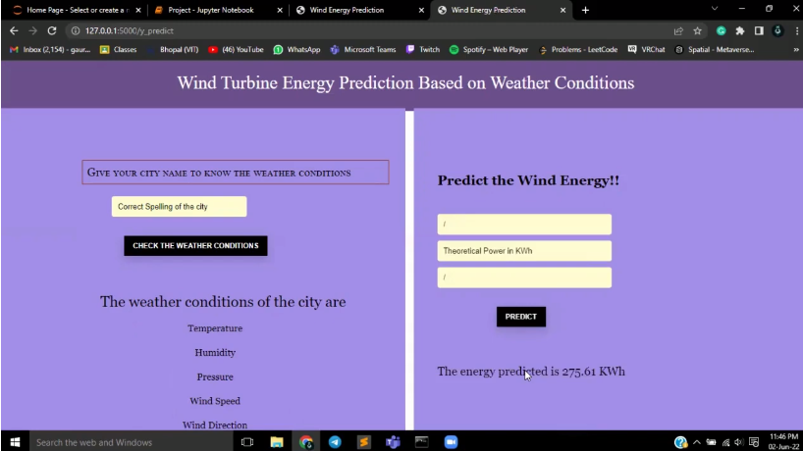

REFERENCES :

[1] O. Kramer and F. Gieseke. Short-term wind energy forecasting using
support vector regression. In International Conference on Soft Computing Models in Industrial and Environmental Applications, pages 271–280. Springer, 2011.
[2] A. Kusiak, H. Zheng, and Z. Song. Short-term prediction of wind farm Power: A data mining approach. IEEE Transactions on Energy Conversion, 24(1):125 – 136, 2009.
[3] R. Poli, W. B. Langdon, and N. F. McPhee. A Field Guide to Genetic Programming. lulu.com, 2008. ISBN 978-1-4092-0073-4.
[4] M. Schmidt and H. Lipson. Age-fitness Pareto optimization. In Genetic Programming Theory and Practice VIII, Genetic and Evolutionary Computation, chapter 8, pages 129–146. Springer, 2010.
[5] I. Sanchez. Short- term prediction of wind energy production. International Journal of Forecasting, 22(1):43 – 56, 2006.
[6] M. Webb and S. Scuglia. Wind power: A favored climate change response. Global Economic Research: Fiscal Pulse (Scotia bank), 2007.

Github-Demo link

https://drive.google.com/file/d/1sA4skQioXRjELG2DPuZRTvCX1yHAAjrH/view?usp=share_link

